# Code Interpretation

## Problem #1

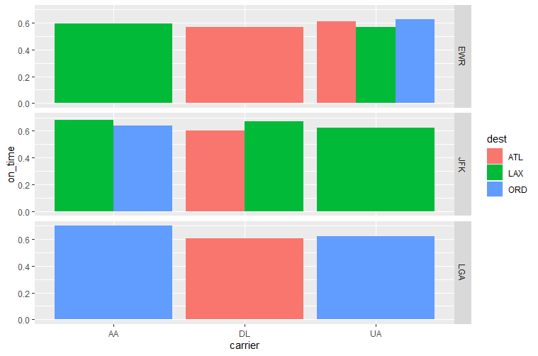

## Problem #2

